# **PR-COIN Research Proposal and Data Request Form**

**Instructions**

Please answer the questions in this form to the best of your ability. Your proposal will be evaluated based on the following criteria:

* The data can be used to address study aims (feasibility).
* The methods are suitable to the question.

*(Please note that in reviewing the application, the Scientific Development and Oversight Committee (SDOC) prioritizes the use of rigorous scientific methods with intent is to ensure that the results are likely to be valid).*

* The study is in line with PR-COIN’s mission.
* There is no significant overlap with an existing study using the PR-COIN registry.
* The study is affiliated with an IRB that can provide oversight and enforce sanctions in the event of a breach of contract.
* Data Analysis Center (DAC) services at Seattle Children’s Research Center include:
* Initial consult with the PR-COIN DAC team (up to 2 hours)
* Grant preparation, for grants where PR-COIN DAC services are written into the grant (depending on grant complexity up to 10 hours). PR-COIN DAC services must be written into all grants utilizing DAC grant preparation.
* Data analysis

* We are also working on a solution that will allow the principal investigator have access to PR-COIN data in a secure SCRI environment which ensures that the dataset remains on SCRI servers.

Any concerns regarding process or delay in Research and Data Request Process, please contact [pr-coin@seattlechildrens.org](mailto:pr-coin@seattlechildrens.org)

For a complete submission package, please return the following documents to [pr-coin@seattlechildrens.org](mailto:pr-coin@seattlechildrens.org). Feel free to email with any questions you may have.

* Completed Research Proposal and Data Request Form
* Proposal (instructions below)
* Principal Investigator NIH Bio-sketch
* Mentor Letter of Support (if applicable)

Review Process:

* There will be two cycles for proposal review in March and September of each calendar year.
* 2-3 proposals will be chosen per cycle based on attributes in keeping with PR-COIN’s mission, vision and core approach to patient centered care. <https://www.pr-coin.org/mission-vision-and-approach>
* Proposals that are deemed appropriate but unable to be approved during the submitted cycle will be considered for the following cycle upon PI(s) approval.
* Upon submission of a complete package, your proposal documents will be reviewed by SDOC Committee members.
* The proposal will be presented and discussed by the Scientific Development and Oversight Committee.
* A determination of Approved, Provisional Approval, or Decline, will be assigned during the Committee Meeting and presented to the Steering Committee for final approval.
* PI’s will receive an email notification of the determination with supporting comments in April or October depending on the cycle the application is received.

|  |  |
| --- | --- |
| **Proposal Request Form** | |
| **Proposal Date:** Click or tap here to enter text. | |
| **Proposed Project Title:**  Click or tap here to enter text. | |
| **Principal Investigator:** Click or tap here to enter text. | |
| Name: | Click or tap here to enter text. |
| Position/Title: | Click or tap here to enter text. |
| Institution: | Click or tap here to enter text. |
| Email Address: | Click or tap here to enter text. |
| Phone: | Click or tap here to enter text. |
| Link to Bio-sketch: | <https://grants.nih.gov/grants/forms/biosketch.htm> |
| **Additional Key Personnel/Co-Investigators:**  Please include Name, Degree(s), Position Title, Institution (if differs from PI’s)  Click or tap here to enter text. | |
| **Mentor Name (if applicable)**  Please include Name, Degree(s), Position Title, Institution, Qualifications  Click or tap here to enter text. | |
| **Proposal/ Grant Study Start and End Dates:** Click or tap here to enter text. | |
| **Overall Study Question (and primary hypothesis to be tested):**  Click or tap here to enter text. | |
| **Lay Summary of Project (maximum 200 words). Please be concise and use plain language for non-specialists to understand.**  Click or tap here to enter text. | |
| **Type of Design Category:**  Please check one.  Pre-award grant preparation (please provide your protocol or your grant sponsor information)  Observational (includes retrospective and prospective)  Interventional (includes randomized trial)  Other, please specify: Click or tap here to enter text. | |
| **Will data beyond a limited dataset be used or prospective data collected?**  Please check one  Yes, and plans for consenting patients are in place  Yes, and Consent is not planned  No | |
| **Does this proposal have existing funding?**  Yes, please list sponsor: Click or tap here to enter text.  No | |
| **Does the primary author submit data to the PR-COIN registry?**  Yes  No | |
| **Do you have existing code that can be used for your project?** We can use your code for this project to potentially expedite data review. *  Yes  No | |
| **If external to PR-COIN, are you interested in collaborating and being connected with additional PR-COIN investigators? Please specify planned collaborator(s) and their institution(s) if already identified in space below.**  Yes  No  **List Collaborators and Their Institutions:**  Click or tap here to enter text. | |
| |  |  | | --- | --- | | **Proposal Details** | | | **Provide below a summary of the proposal focusing on the study question and the methods for answering that question.**  Include the following information: | | | 1. **Background and Significance (no more than 1-2 paragraphs):**   Click or tap here to enter text. | | | | 1. **Relevance to PR-COIN’s Mission, Vision, and Approach (see below after this form):**   Click or tap here to enter text.   1. **Specific Aims:**   Click or tap here to enter text. | | | | 1. **Methods (1-2 page summary including the detailed information below):**  * Study design * Surveys or questionnaires (if applicable)* * Study population * Estimated sample size * Selection/recruitment of participants * Proposed inclusion/exclusion criteria * Data sources * Required variables (see enclosed data dictionary) * Basic analysis plan for this stage of the study. Please indicate descriptive versus outcome variables. * Pre-specified subgroup(s) of interest * Duration: approximate study timeline (starting from time of approval) | | | *\*If a survey or questionnaire will be used, describe the survey tool and indicate how it has been tested for validity and reliability. Submit a copy of the survey and consent language as an appendix. Consent language (verbal or on the face page of electronic survey), such include, but might not be limited to, voluntariness, assurance that answers and/or participation (or lack thereof) will not affect clinical care or legal rights for them or their child.*  Click or tap here to enter text. | | | 1. **Potential Risks and Benefits**   Click or tap here to enter text. | | | 1. **Plan for patient and stakeholder engagement (if applicable):**   *Describe current or planned patient/caregiver engagement in the proposed research such as inclusion on the study team or service in an advisory role.*  Click or tap here to enter text. | | | 1. **Health equity considerations/plan (if applicable):**   Click or tap here to enter text.   1. **Anticipated impact on patient decisions and/or clinical outcomes:**   Click or tap here to enter text. | | | 1. **References**   Click or tap here to enter text. | | | |

**Mission**

The mission of PR-COIN is to build a thriving and inclusive community of patients, families, clinical teams and researchers that uses quality improvement science to deliver exceptional and equitable health care to children with rheumatic diseases and to bring research discovery to patients faster.

**Vision**

Children with rheumatic diseases will have excellent health outcomes under the care of highly effective pediatric rheumatology teams.

**Approach**

To achieve our mission and vision, the PR-COIN community will:

Empower patients and families to partner with their doctors and clinic teams for more engaged and productive visits

Provide training in quality improvement methods and cultivate high functioning clinical teams to provide effective, efficient, equitable, and innovative rheumatology care

Use a shared registry of patient data to measure performance, identify gaps in care, and drive improvement strategies to close these gaps

Enable research discovery by collaborating with investigators within PR-COIN and the wider scientific community to analyze robust clinical-practice data in our registry and study impact of health care delivery interventions

Create a peer community where members can rely on each other for support, advice, and insights leading to successful approaches to improving care

Include patient families in all levels of governance and network activities to ensure patient-centered care

Share and implement best practices so children get the best quality pediatric rheumatology care everywhere

Increase joy in work for a more productive and vibrant pediatric rheumatology workforce

**OUR CORE VALUES**

PR-COIN commits to the following core values on our improvement journey:

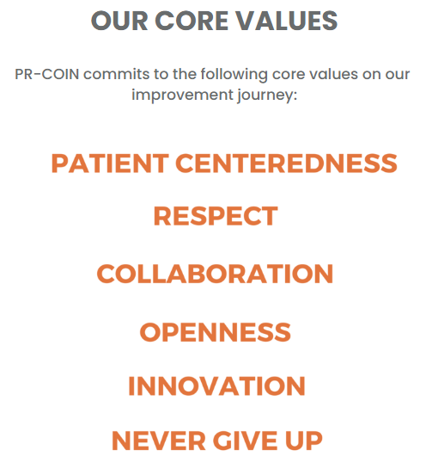

As a service to PR-COIN members and in reference to existing legal agreements, the DAC will conduct data analysis and abstract/manuscript preparation (e.g., results). If grant application is pursued, then inclusion for budgetary support of the DAC is expected for support for these functions.

