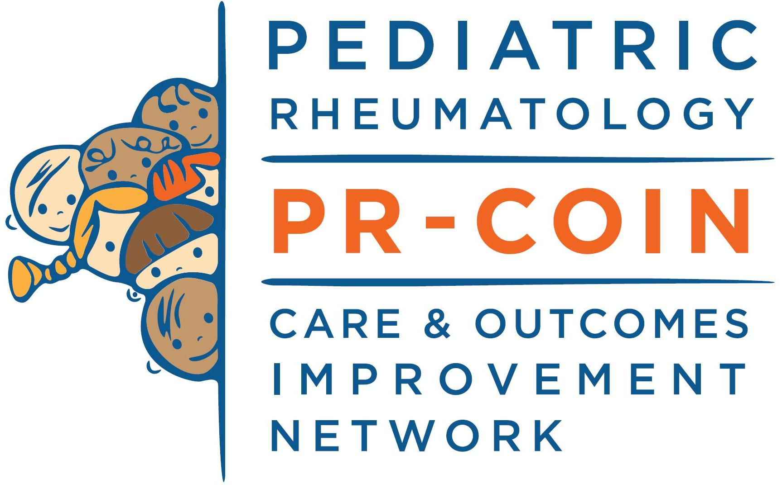

**Quality Improvement Collaborative**

**APPLICATION**

**PACKET**

[www.pr-coin.org](http://www.pr-coin.org)

**Funders and Partners**

*We are grateful for support from:*

Anonymous donors

Abby’s Army

MacDonald Foundation

Seattle Children’s Research Institute

PR-COIN Member Centers and Volunteers

*We have received grant funding or support from:*

Agency for Healthcare Research and Quality

American College of Rheumatology

Arthritis Foundation

Patient Centered Outcomes Research Institute

Pfizer

The Cincinnati Children’s Hospital Research Foundation

Updated January 2024

TABLE OF CONTENTS

Letter of Introduction 4

Application Checklist 7

Organizational Structure & Governance 8

PR-COIN Key Driver Diagram 9

Participant Organizational Contacts 10

Participating Center Profile 11

Participant Team Roster 13

Senior Leader/Administrator Agreement 14

# Letter of Introduction

Dear Colleague,

Welcome - we are delighted that you are interested in being a participant center in the Pediatric Rheumatology Care and Outcomes Improvement Network (PR-COIN)!

Launched in 2011, PR-COIN is comprised of over 325 members across 24 participating centers in the United States and Canada. ***The founding mission*** of PR-COIN is to dramatically improve the outcomes of care for children with rheumatic conditions. Our strategy is to harness the inherent motivation and unique expertise of all stakeholders, including patients and caregivers, clinicians, researchers, and community partners, and apply structured quality improvement methods, advanced information technology systems, and sharing of best practices to track and continuously improve health outcomes for children with rheumatic conditions across North America. While the initial focus of PR-COIN was on children with juvenile idiopathic arthritis (JIA), we will target outcomes improvement in systemic lupus erythematosus in the near future, and plan to expand to other rheumatic conditions over time. Our website provides additional insight into the Mission, Vision and Core Values of PR-COIN at [www.pr-coin.org](http://www.pr-coin.org).

We invite you to join us in this important work and believe PR-COIN will provide great value to your center and patients as current PR-COIN participants have learned important QI skills, their patients have benefitted from access to materials co-produced by PR-COIN with parents, and centers have adopted best practices for care delivery through collaboration within PR-COIN.

**PR-COIN Operations**

PR-COIN strives to achieve this mission in partnership with the coordinating center and all participating sites through monthly webinars, harnessing the power of PR-COIN's collaboration platform which includes our online QI Tools, registry and document repository. In addition, monthly webinars, QI consultations, and bi-annual learning sessions are a routine part of PR-COIN. Site members are also encouraged to join available PR-COIN committees which help drive various PR-COIN initiatives and activities.

With guidance from experts in quality improvement and chronic care delivery, participating centers collect and share clinical data, and identify and share best practices across the network. Centers test specific changes in their local care processes to determine how to incorporate improvements into daily practice, which may include redesigning how care is delivered to achieve better outcomes. Each center assembles a local QI team responsible for center improvement activities, data capture, and attendance at PR-COIN learning sessions with other centers. The PR-COIN Coordinating Center provides QI training and arranges mentorship for participating centers, conducts semi-annual in-person learning sessions and monthly webinars, and leverages a registry that provides data reports to centers to facilitate improved care for patients.

At each participating center, data about patients, disease status, and care provided is captured from every clinical visit. Teams may enter data into the PR-COIN registry using web forms. Data can also be mapped to the PR-COIN registry from electronic health records or registries (e.g., REDCap) for electronic data transfer. For Epic EHR users, we have developed a Smartform that facilitates a “data-in-once” strategy. The goal is to work with information services at each center and other EHR vendors to capture most clinical data during clinic visits to allow direct upload into the PR-COIN registry. Data from current and previous months are analyzed and summary reports and graphic displays provided back to centers to facilitate and improve the care they provide. Reports available to centers include: provider level, center level and network level performance on key clinical process and outcome measures over time, a population management report with patient-level detail regarding patient outcomes and care, a data quality report, and a pre-visit planning report with individual patient data and decision support to help teams prepare for upcoming visits.

Each center can review data reports to identify gaps in care and outcomes and perform Plan-Do-Study-Act cycles to close the gaps while collecting data to determine the effectiveness of changes they make. To better facilitate quality improvement at centers, quality improvement tools are available within the registry platform. Teams can create and collaborate on shared Key Driver Diagrams and Plan-Do-Study-Act test cycles. With this iterative process of continuous quality improvement, changes are made in the way care is delivered at your center, resulting in improvements in the care and outcomes.

Additionally, PR-COIN provides group QI training and individualized coaching to support the teams in local QI activities. Educational activities include webinars and in person learning sessions where best practices and effective interventions are shared with all participating centers, enabling each center to benefit from the work of others. To facilitate communication among the centers, there is a member only PR-COIN website containing tools and reports that centers can download on-demand. In addition, there is a newsletter and knowledge sharing platform for our network to stay connected.

**PR-COIN enables providers at each center to:**

* Learn and apply principles of the Model for Improvement and the Chronic Care Model to improve care and outcomes for their patients
* Partner with patients and families to co-produce health through better systems of care
* Establish systems for measuring and tracking performance
* Work together to establish best practices
* Collaborate and share tools and materials with other centers that aid improved care delivery
* Design and participate in research
* Meet requirements for maintenance of certification, Part IV (MOC) by the American Board of Pediatrics

**PR-COIN fosters collaboration and organizational growth by taking steps to:**

* Support the network to achieve these goals
* Organize and present conference calls and learning sessions for all centers
* Coach centers in applying a systems framework to patient care, including systematically implementing and evaluating changes in care
* Develop and implement a structured QI framework for testing changes in care delivery across all participating centers
* Provide best-practice information on care and tools, forms, and other aids to help with implementation of changes
* Coordinate communication across all centers to provide participants with analyses regarding the effectiveness of changes and work of their colleagues
* Develop measures for tracking network performance and a repository of interventions for application and testing
* Provide secure HIPAA-compliant data management, including electronic data entry, data storage, and data analysis
* Work with centers to develop systems of efficient data capture with the goal to achieve “data-in-once” with automated upload of clinical data into the PR-COIN registry
* Partner with existing networks in pediatric rheumatology to complement their missions, in part by developing efficient capture and sharing of clinical data
* Facilitate comparative effectiveness research across centers and the network

**Each participating center plays a vital role within the network by:**

* Having a QI team (e.g., a physician, a nurse, and one other staff member for data entry and to oversee improvement), including a physician leader that will organize, lead and advocate for improvement efforts at the center. It is recommended to include a parent on the team to foster a patient-centered approach.
* Entering relevant clinical data about all JIA patients receiving care at the center into the PR-COIN Registry
* Providing access to local IT support to configure the EHR to support automatic upload of clinical data
* Enabling team members, including the physician leader, to attend all learning sessions, providing support for their travel and accommodations
* Providing resources and support to the center team, including time to devote to testing and implementing changes in one or more of the target areas of rheumatology care
* Completing and participating in presentations (at least 1 per year) and pre-work activities (at least biannually) to prepare for conference calls, webinars, and learning sessions
* Communicating local updates that may influence PR-COIN participation in a timely fashion with the Network organizers
* Participating in conference calls, webinars, and other activities to communicate, share and learn with other centers.
* Making defined measurements at least monthly and sharing the results with PR-COIN and other participating centers
* Ensuring compliance with center institutional review board/ethics board reporting requirements
* Paying an annual participation fee of $15,000

**PR-COIN's funding model is:**

A large portion of the network’s revenues comes from annual participation fees, which help defray the cost of maintaining the registry and delivering the QI tools and training. Supplemental sources of funding for the network include a) foundation and other grants, b) philanthropic support, and c) industry sponsorship.

We are thrilled with your interest in joining this exciting collaborative effort that will transform care and improve outcomes for children with rheumatic disease. We look forward to speaking with you soon. In the meantime, please feel free to contact us should you have any questions.

Sincerely,

*Esi*

Esi Morgan, MD, MSCE

Head, Division of Rheumatology, Seattle Children’s Hospital

Professor of Pediatrics, University of Washington

PR-COIN Principal Investigator and Steering Committee Chair

on behalf of the Pediatric Rheumatology Care and Outcomes Improvement Network

[www.pr-coin.org](http://www.pr-coin.org)

[PR-COIN@seatttlechildrens.org](mailto:PR-COIN@seatttlechildrens.org)

|  |
| --- |
|  |

# Application Checklist

This application packet serves the purpose of enrollment in PR-COIN. By joining PR-COIN, you agree to implement QI principles at your centers, and work alongside PR-COIN member centers to include patients and caregivers in your research and/or quality improvement initiatives, and support the spread of best practices to all patients and families served. Please make sure to return the application to the PR-COIN Coordinating Center once this application is fully completed with signatures ([PR-COIN@seatttlechildrens.org](mailto:PR-COIN@seatttlechildrens.org)). The PR-COIN Coordinating Center is responsible for on-boarding centers into PR-COIN.

Note: An important factor for success is the support of a senior or executive leader in assuring your team has the resources and time to engage in improvement activities and realize the full benefit of PR-COIN membership. **We strongly recommend your site form an improvement team that is representative of your clinic, with members such as clinicians (MD/DO/NPs), nurses, MA, PT/OT, SW, clinic staff, coordinators (consent, data entry), and parent and/or patient advisors.**

**Step 1: Complete the Application Packet**

Please review this packet and complete and return the following forms to [PR-COIN@seattlechildrens.org](mailto:PR-COIN@seattlechildrens.org):

Participant Organizational Contacts (see p. 10)

Participating Center Profile (see p. 11-12)

Participant Team Roster (see p. 13)

Senior Leader/Administrator Agreement (see p. 14)

**Step 2: Upon approval and admittance to PR-COIN, the PR-COIN Coordinating Center will support your team in completing these remaining required activities:**

*Regulatory approval for participating in registry activities is required.* Seattle Children’s can serve as the Institutional Review Board (IRB) of record for your institution through the reliance protocol (Note: It is up to each participating institution to determine whether a reliance protocol would be acceptable). Alternatively, submission of local human subjects’ research protection regulatory documents may be required by your local hospital or clinic. The PR-COIN Coordinating Center can support your local IRB application by providing reference documents from the approved protocol at Seattle Children’s.

*Fully executed data sharing legal agreements are required to enable data submission, reporting, and analysis****.*** More specifically, the two required agreements are:

1) The “Participation and Data Use Agreement” (PDUA), which permits the transfer of your team data to the PR-COIN registry for analysis.

2) The Business Associate Agreement, which permits Seattle Children’s to act as a business associate and complete the QI services stated in the PDUA.

Please be advised that PR-COIN charges an annual membership fee for participating centers. The participating fee will be billed on an October 1st to September 30th cycle, annually, with prorating as needed. The participating fee is $15, 000 for FY 2023 – 2024, (this amount was established 5 years ago and may be adjusted for inflation/rising operational costs in the coming period).

**New centers will not be able to access members only materials and the registry until the participation agreement has been returned and the participation fee has been remitted to the Coordinating Center. Additionally, data submission cannot begin until both legal agreements and IRB approval are finalized. We strongly encourage you to start this process as early as possible by connecting your legal and IRB experts to the PR-COIN Coordinating Center (**[PRCOIN@seatttlechildrens.org](mailto:PRCOIN@seatttlechildrens.org)**).**

**Step 3: The PR-COIN Coordinating Center will onboard your team through an onboarding process.**

Please direct all questions and correspondence to [PR-COIN@seatttlechildrens.org](mailto:PR-COIN@seatttlechildrens.org)

# Organizational Structure & Governance

PR-COIN’s Organizational Structure is composed of a leadership team which includes an Executive Committee and a larger Steering Committee with broad representation of the network. Committees work in teams to address functional areas within the network, including Outcomes Improvement, Measures (Reports), Informatics and Technology (Registry), Scientific Oversight and Development (Research), Family Engagement (Patient and Parent Workgroups), and Finance and External Partnerships. The PR-COIN Coordinating Center provides project management support to the PR-COIN learning health network. An external vendor is contracted to manage the registry. A separate Data Analytic Center at Seattle Children’s Research Institute oversees data management, research analytics and biostatistics.

For more information about our organizational structure, please contact us at

[PR-COIN@seatttlechildrens.org](mailto:PR-COIN@seattlechildrens.org).

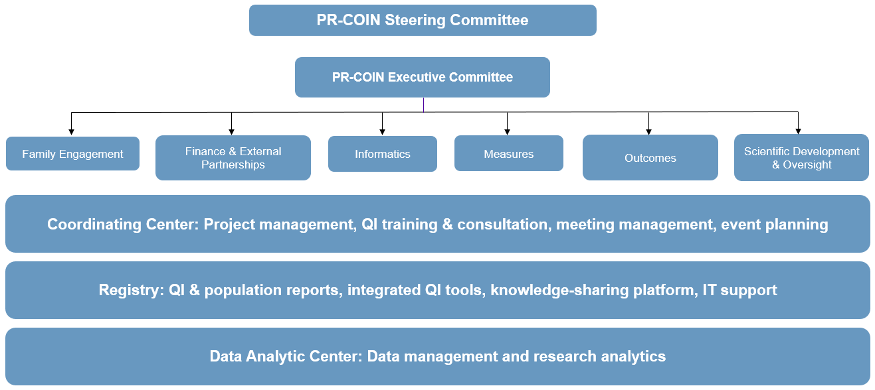

# PR-COIN Key Driver Diagram

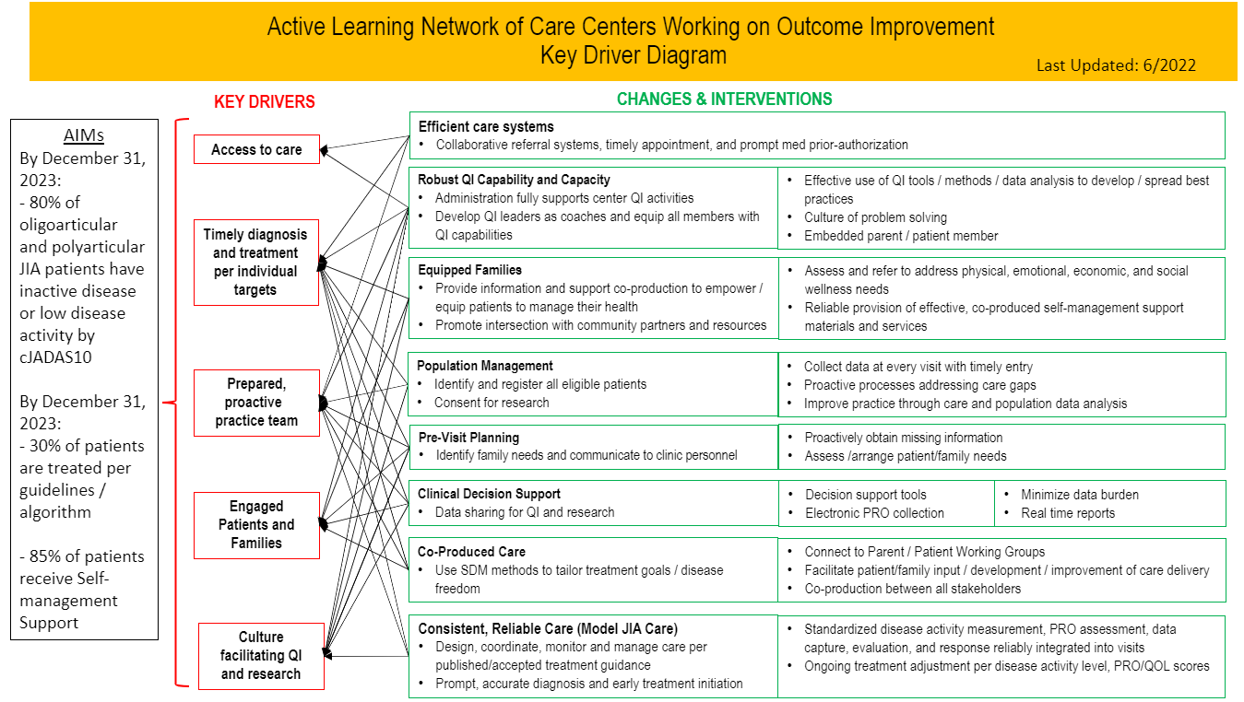

# Participant Organizational Contacts

**Complete and return this form along with all other required forms to** [**PR-COIN@seattlechildrens.org**](mailto:PR-COIN@seatttlechildrens.org)**.**

|  |  |
| --- | --- |
| **Organization Name:** Click or tap here to enter text. | **Date:** Click or tap here to enter text. |
|  |  |
| **Lead Physician Name:** Click or tap here to enter text. | |
| **Title:** Click or tap here to enter text. |  |
| **Address:** Click or tap here to enter text. |  |
| **City:** Click or tap here to enter text. | **State:** Click or tap here to enter text. |
| **Zip/Postal Code:** Click or tap here to enter text. |  |
| **Phone:** Click or tap here to enter text. | **Email:** Click or tap here to enter text. |
|  |  |
| **Key Contact** **Person Name** (for typical correspondence): Click or tap here to enter text. | |
| **Phone:** Click or tap here to enter text. | **Email:** Click or tap here to enter text. |
|  |  |
| **IRB Contact Name(s)**: Click or tap here to enter text. | |
| **Phone:** Click or tap here to enter text. | **Email:** Click or tap here to enter text. |
|  |  |
| **Legal Contact Names(s)**: Click or tap here to enter text. | |
| **Phone:** Click or tap here to enter text. | **Email:** Click or tap here to enter text. |
|  |  |
| **Hospital QI Director Name(s)**: Click or tap here to enter text. | |
| **Phone:** Click or tap here to enter text. | **Email:** Click or tap here to enter text. |

# Participating Center Profile

Interested sites should please complete the information below and return your completed application to [PR-COIN@seatttlechildrens.org](mailto:PR-COIN@seatttlechildrens.org)

|  |  |  |
| --- | --- | --- |
| **Site Name:** Click or tap here to enter text. | | |
| **Site Address:** Click or tap here to enter text. | | |
|  | | |
| **Name of person completing this application:** Click or tap here to enter text. | | |
| **Title:** Click or tap here to enter text. | | |
| **Email:** Click or tap here to enter text. | **Phone:** Click or tap here to enter text. |

**­­­­­­­­­­­­­**

|  |  |
| --- | --- |
| 1. **Briefly describe the aspects of your hospital/clinic/organization that relate to care of the child with a rheumatologic condition** (clinic size, providers e.g. doctors, physician assistant, nurse practitioners, number of nurses) hospital based or outreach clinics, location (specify; urban, rural, suburban), social worker in clinic. | |
| Click or tap here to enter text. | |
| 1. **Please estimate the number of children your site sees each year with *newly diagnosed JIA*:** | | |
| Click or tap here to enter text. | | |
| 1. **Estimated total number of JIA patients followed by your center (i.e., number of unique JIA patients seen over past 15 months):** | | |
| Click or tap here to enter text. | | |
| 1. **At routine clinic appointments, are any of the following data collected:** | | |
| * 1. Pain Intensity Scores | Yes  No | |
| * 1. Physical Function Measure | Yes  No | |
| *If yes, please specify which ones:* | Click or tap here to enter text. | |
| * 1. Mental Health Measure | Yes  No | |
| *If yes, please specify which ones:* | Click or tap here to enter text. | |
| * 1. Physician Global Assessment of Disease Activity | Yes  No | |
| * 1. Parent Assessment of Overall Well-being | Yes  No | |
| 1. **Does your pediatric rheumatology team utilize an electronic health record (EHR)? Please describe (name/vendor, version, how long have you been using this EHR).** | | |
| Click or tap here to enter text. | | |
| * 1. *If not currently on an EHR, any plans to adopt an EHR in future? Vendor selected?* | Click or tap here to enter text. | |
| * 1. *If currently on an EHR, any plans to switch vendors?* | Click or tap here to enter text. | |
| 1. **Does your pediatric rheumatology team utilize a physical therapist and/or occupational therapist as part of your outpatient clinical team on a regular basis? Please describe resources available to you for rehabilitation support.** | | |
| Click or tap here to enter text. | | |
| 1. **Briefly describe any experience that you or others have in initiating successful improvement activities, participating in a learning network or any experience with measurement of quality outcomes.** In what topic area(s)? Do you have quality improvement support within the unit structure or from the hospital? Examples of this support include: data collection, team facilitation, meeting documentation and planning for improvement activities aimed at helping you accomplish your goals. | | |
| Click or tap here to enter text. | | |
| 1. **Briefly describe what your organization wants to accomplish as a participant in PR-COIN:** | | |
| Click or tap here to enter text. | | |
| 1. **Please add any additional information about your setting that may be relevant to this project:** | | |
| Click or tap here to enter text. | | |

# Participant Team Roster

A site core team typically consists of a physician or nurse practitioner lead, a member of the ancillary nursing staff, administrative or clerical staff members, and others as meets your needs. PR-COIN advocates the inclusion of patients / family members interested in improving team processes and outcomes.

Please submit contact information for ALL Team Members.

|  |  |  |
| --- | --- | --- |
| **Key Contact**  The Key Contact serves as the day-to-day liaison to disseminate **from and communicate with the** PR-COIN **Coordinating Center** and coordinate team activities **(ex.** parent outreach, regular improvement team meetings, managing improvement responsibilities**,** and ensuring reports and/or data are collected and reported**)**. **We recommend** the Key Contact not be a physician **or the site PI**. | | |
| Name: Click or tap here to enter text. | Title: Click or tap here to enter text. |
| Phone: Click or tap here to enter text. | Email: Click or tap here to enter text. |
| **Team Member** | | |
| Name: Click or tap here to enter text. | Title: Click or tap here to enter text. |
| Phone: Click or tap here to enter text. | Email: Click or tap here to enter text. |
| **Team Member** | | |
| Name: Click or tap here to enter text. | Title: Click or tap here to enter text. |
| Phone: Click or tap here to enter text. | Email: Click or tap here to enter text. | |
| **Team Member** | | |
| Name: Click or tap here to enter text. | Title: Click or tap here to enter text. |
| Phone: Click or tap here to enter text. | Email: Click or tap here to enter text. | |
| **Team Member** | | |
| Name: Click or tap here to enter text. | Title: Click or tap here to enter text. |
| Phone: Click or tap here to enter text. | Email: Click or tap here to enter text. | |
| **Team Member** | | |
| Name: Click or tap here to enter text. | Title: Click or tap here to enter text. |
| Phone: Click or tap here to enter text. | Email: Click or tap here to enter text. | |
| **Team Member** | | |
| Name: Click or tap here to enter text. | Title: Click or tap here to enter text. |
| Phone: Click or tap here to enter text. | Email: Click or tap here to enter text. | |
| **Team Member** | | |
| Name: Click or tap here to enter text. | Title: Click or tap here to enter text. |
| Phone: Click or tap here to enter text. | Email: Click or tap here to enter text. | |
| **Please copy and paste more rows to add additional team members as necessary.** | |

# Senior Leader/Administrator Agreement

*The Senior Leadership (e.g., Division Director or Department Chair) are persons outside the improvement team with administrative oversight for the clinical area who can materially and politically support the improvement team in this endeavor, including removing barriers to improvement.*

|  |  |
| --- | --- |
| **Name:** Click or tap here to enter text. |  |
| **Title:** Click or tap here to enter text. |  |
| **Phone:** Click or tap here to enter text. | **Fax:** Click or tap here to enter text. |
| **Email:** Click or tap here to enter text. |  |

|  |
| --- |
| *As Senior Leaders, we understand the project’s objectives and expectations, and pledge to support our team in their data collection and improvement work by reducing barriers and providing resources necessary to achieve PR-COIN quality improvement goals and greater integration with the research and patient community. Example activities include team meetings, conduct of Plan-Do-Study-Act tests, data collection and entry, and participation in PR-COIN meetings and conferences. Furthermore, I agree our center will remit the participation fee annually to join the network. I understand full payment of the annual participation fee is required to receive full privileges of PR-COIN membership. Most teams participate in the network on a long-term basis, and we understand this commitment will likely last over a minimum of 5 years, with an option to withdraw after providing notice.* |

This signature page must be received with your application for your application to be considered. Please return all completed forms to [PR-COIN@seatttlechildrens.org](mailto:PR-COIN@seatttlechildrens.org).